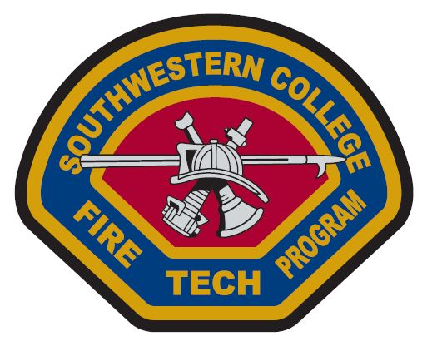
Southwestern College State Fire Training Classes – 2014
(Please email instructor to initiate enrolling in the class.)
Class/Number | SWC # | Instructor | Dates of class
Command 1 - Structure Fire Command Operations for Company Officer | CS1002OM | Lou Duarte  lduarte@swccd.edu | 1/21/14 – 1/25/14,  4/21/14 – 4/25/14
Command 2 Fire Command 1B | CS1003OM | Steve Bowlin  sbowlin@swccd.edu | 2/03/14 – 2/07/14,  5/12/14-5/16/14
Fire Instructor 1 (Training Instructor 1A: Cognitive Lesson Delivery) | CS1004OM | Lou Ortiz  lortiz@swccd.edu | 1/27/14-1/31/14,  4/7/14-4/11/14
Fire Instructor 2 (Training Instructor 1B: Psychomotor Lesson Delivery) | CS1005OM | Lou Ortiz  lortiz@swccd.edu | 2/24/14-2/28/14, 5/5/14-5/9/14
Fire Instructor 3 (Training Instructor 1C: Instructional Development Techniques) | CS1006OM | Lou Ortiz  lortiz@swccd.edu | 3/3/14-3/7/14, 5/19/14-5/23/14
Fire Investigation 1A | CS1007OM | John Jerome  jfjerome@me.com | 12/9/13-12/13/13
Fire Investigation 1B | TBA | John Jerome  jfjerome@me.com | 2/10/14-2/14/14
Fire Management 1 | CS1008OM | Dane Cawthon  Dane.cawthon@gmail.com | ??
Prevention 1 (CS1000OM) | CS1000OM | John Jerome  jfjerome@me.com | 3/10/14-3/14/14
The cost of each class is $285 and includes the state certificate. Books are extra.
Enrollment information

Step One: Please email the course instructor and they will reserve a spot for you.

Step Two: If you have never taken a course at Southwestern College and don’t have an SWC ID number, please go to www.swccd.edu or www.cccapply.org and fill out the SWC student application form. In 48 hours you will receive your SWC student ID number. If you already have a student ID then you do not need to apply to SWC for a new number.

Step Three: Make a CASHIERS CHECK made payable to SWC with your student ID number in the memo section. Mail the cashier’s check and a self-addressed stamped envelope to the address given to you by the instructor. Instructor will confirm and send you the syllabus and textbook information.

Classes are held at the Higher Education Center at Otay Mesa; 8100 Gigantic St., San Diego CA 92154

