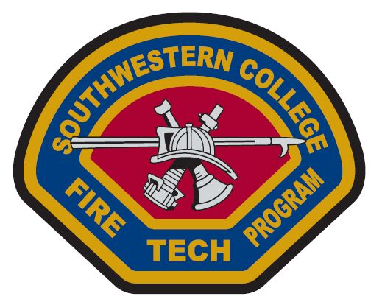

Southwestern College
State Fire Marshall
Fall 2016

Fire Investigation 1A: November 28-December 2, 2016
Student Information:

SWC ID number: __________________________

NAME: __________________________________EMAIL:_________________________________

ADDRES_________________________CITY__________________ZIP:________________

PHONE: ________________________

DEPARTMENT___________________________________

Note:
- Please mail this sheet with your payment to:

Southwestern College Higher Ed Center
Attn: Student Services
8100 Gigantic St.
Sna Diego CA 92154

