Proposed Parking Lot Changes
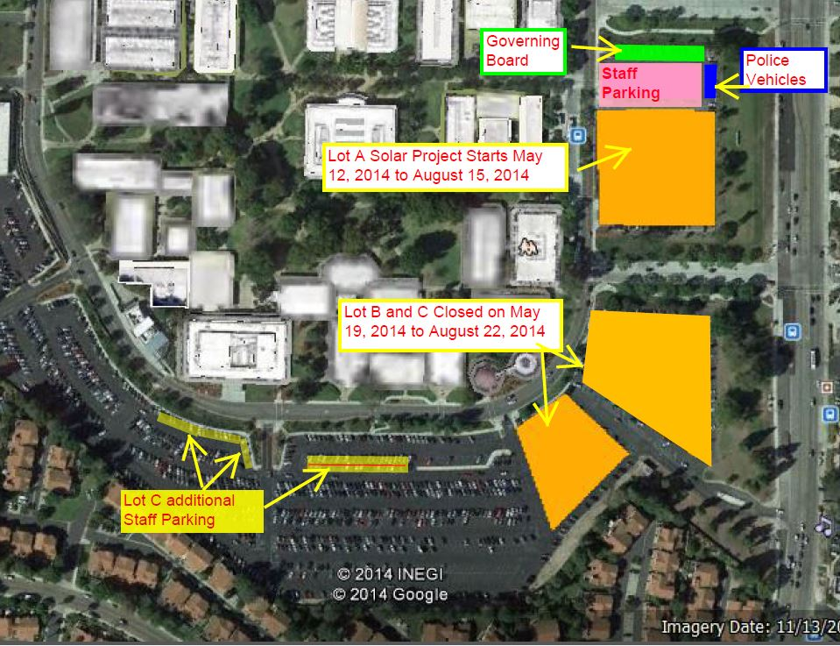

LOT A

Along the perimeter road on the west side is where the Superintendent/President’s space and then the Governing Board spaces will be this is indicated by the green box. The corner space will be for the Police trailer and then the spaces to the right section will be for the Police vehicles indicated by the blue box. The MTS space will be the last space designated. Following the MTS space and throughout the rest of the lot it will be staff spaces.
Dispenser
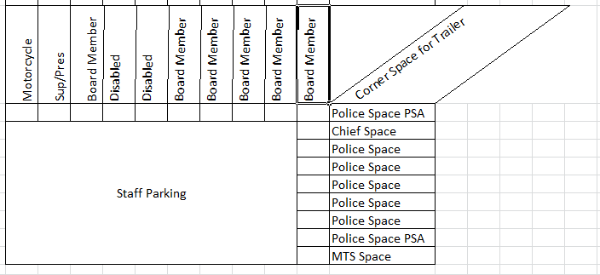

Lot O

We are proposing to take the West portion of the parking lot that is against the perimeter road and change that to visitor parking indicated by the yellow box. A visitor permit is required.
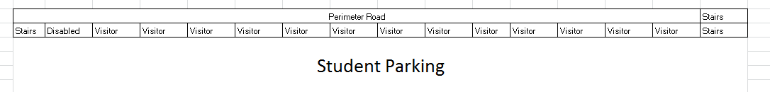LOT C
There will additional staff parking (see map for location) starting 5.19.14.

